TNE20003 – Internet and Cybersecurity

Portfolio Task – Lab 1 Pass Task

Aims:
- To build and understand basic network infrastructure
- To build a simple network with Cisco Packet Tracer and observe the data flow within the network

Preparation:
- View “Topic 1 – Network Toplogies, Concepts and Protocol”
- Perform tasks instructed in the Unit Canvas – Packet Tracer.
- Please note that task1 must be done at home before the lab!

Due Date:
- Task1 must to be completed before the lab and uploaded to Canvas. Your demonstrator will check the answers to the questions and your diagram for task 1 and may ask questions during the lab session. Task 2 will be assessed via an online quiz. You must score at least 75% to pass the test. You will be allowed up to 5 attempts to reach this score. You are encourage to complete the test during the lab but if you do not , you must complete it before your next lab class.

Task 1.
Build an Understanding of Network Infrastructure

In this task, you will
- record all the different devices attached to the network in your home.
- identify how each device connects to the network to send and receive information.
- create a diagram showing the topology of your network and label each device with its function within the network.

Instructions
- Take a close look at the network you have at home.
- Record the network and end-user devices that are connected on your local home network.
For example,
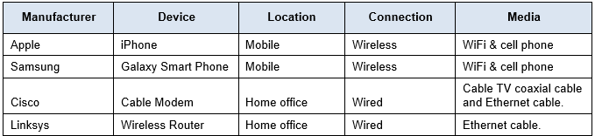

Manufacturer | Device | Location | Connection | Media
Apple | iPhone | Mobile | wireless | WiFi & cell phone
ASUS | Laptop | Mobile | wireless | WiFi
TP-Link | Wireless Router | Home | wired | Ethernet

- Are there other electronic devices that are not connected to the local network to share information or resources?
Fridge, calculator, air conditioner, heater. All electronic devices however are not ‘smart devices’ in the sense that they are not connected in any way to the home network.
Bluetooth speaker, wireless mouse
- Which type of connectivity is used most frequently in your local network, wired or wireless? Explain why.
Wireless – a mobile phone and laptop should be able to move around without a physical connection but remain wirelessly connected to the network. Allowing for better accessibility in terms of moving and using the device.

- Draw a diagram of your local network. Label each device with a name and location. Make sure that you identify how the devices are connected ie wired, optic cable or wireless.

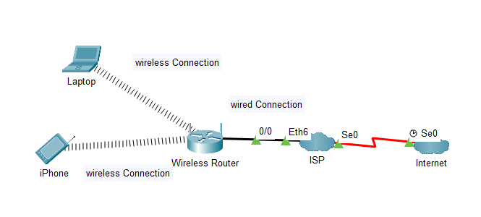

(Wireless router connects to ISP provider in some way, but regardless it is connected to the internet)
(WiFi connections to end devices and Ethernet connection to ISP/internet)

Sample solution shown below

of document
Task 2.
Build a simple network with Cisco Packet Tracer and observe the data flow within the network
In this task, you will
- Create/model a simple Ethernet network using 1 PC, 1 Server, and a Switch.
- Observe traffic behavior on the network.

Create a logical network diagram with 1 PC, a Server and a switch.
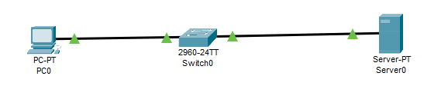
The bottom left hand corner of the Packet tracer screen displays the icons that represent device categories or groups, such as Routers, Switches, or End Devices.
Moving the cursor over the device categories will show the name of the category in the box. To select a device, first select the device category. When the device category is selected, the options within that category appear in the box next to the category listings. Select the device option that is required.
      - Select End Devices from the options in the bottom left-hand corner. Drag and drop 1 PC and 1 Server onto your design area.
      - Select Switch from the options in the bottom left-hand corner. Add a 2960 switch to your prototype network by dragging it onto your design area.
      - Select Connections from the bottom left-hand corner. Choose a copper straight-through cable type. Click the first PC (PC0) and assign the cable to the FastEthernet0 connector. Click the switch (Switch0) and select a connection FastEthernet0/1 for PC0.
      - Repeat step c to connect the Server (Server0). Again using a straight-through cable select FastEthernet0/0 on the Server connect it to FastEthernet0/2 on the Switch.
There should be green dots at both ends of each cable connection after the network has converged. If not, double check the cable type selected.

Configure Host names and IP Addresses on the PC and Server
      - Click PC0. Select the Config tab. Change the PC Display Name to MyPC. Select FastEthernet tab on the left and add 192.168.1.1 as the IP address and 255.255.255.0 as the subnet mask(Hint: If you just press “tab”key or “enter” key on the keyboard after entering the IP address, the mask will be filled in automatically). Close MyPC when done.
      - Click Server0. Select the Config tab. Change the Server Display Name to FileServer. Select FastEthernet tab on the left and add 192.168.1.2 as the IP address and 255.255.255.0 as the subnet mask. Close FileServer when done.
You have just built the simple network shown below.

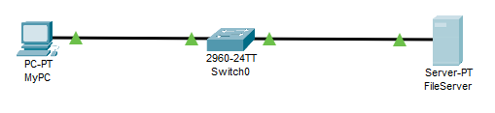

Observe the flow of data from MyPC to FileServer by creating network traffic
      - In the bottom right-hand corner you will find the button for Simulation Mode. Press it to enter that mode.
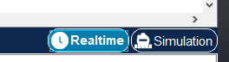
      - Click Edit Filter in the Edit List Filter area. In the event list filter, only select ARP and ICMP filters under IPv4 tab, deselect all other filters in the three tabs IPV4, IPV6 and Misc. The easiest way is to click the ShowAll/None button just above the Simulation button and then just choose the protocols you want to observe.
      - Select a Simple PDU by clicking the closed envelope in the upper toolbar.
With the envelop icon, click MyPC to establish the source. Click FileServer to establish the destination.

Note: Notice that two envelopes are now positioned beside MyPC. One envelope is ICMP, while the other is ARP. The Event List in the Simulation Panel will identify exactly which envelop represents ICMP and which represents ARP.

      - Select Play from the Play Controls in the Simulation Panel.
You can speed up the simulation using the Play Speed Slider. The Play Speed Slider is located below Play inside the Simulation Panel. Dragging the button to the right will speed up the simulation, while dragging is to the left will slow down the simulation.
      - Observe the path of both the ICMP and ARP envelopes.
Click View Previous Event to continue when the buffer is full.
      - Click Reset Simulation in the Simulation Panel.
Notice that the ARP envelop is no longer present. This has reset the simulation but has not cleared any configuration changes or dynamic table entries, such as ARP table entries. If you press Play again you will notice that only the ICMP envelope is sent. The ARP request is not necessary to complete the ping because MyPC already has the MAC address in the ARP table from the previous request.
      - Exit the simulation mode by clicking Realtime.

~~~~~ End of Lab ~~~~~

